Activity – 5

1. Geospatial Data Visualization
Dataset

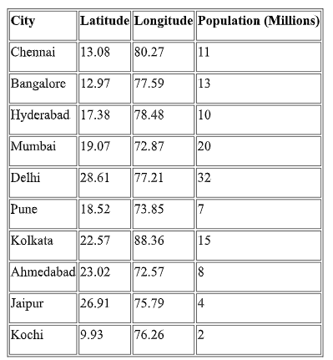
Questions
Q1. Create a scatter map showing all cities using longitude and latitude.
Q2. Plot a bubble map where bubble size represents population.
Q3. Label each city on the plot using geom_text().
Q4. Use different colors based on population size.
Q5. Identify the city with the highest population from the visualization.

Step 1: Create the Dataset
# Load library
library(ggplot2)
# Create dataset
cities <- data.frame(
City = c("Chennai","Bangalore","Hyderabad","Mumbai","Delhi",
"Pune","Kolkata","Ahmedabad","Jaipur","Kochi"),
Latitude = c(13.08,12.97,17.38,19.07,28.61,18.52,22.57,23.02,26.91,9.93),
Longitude = c(80.27,77.59,78.48,72.87,77.21,73.85,88.36,72.57,75.79,76.26),
Population = c(11,13,10,20,32,7,15,8,4,2)
)

Q1.Create a scatter map showing all cities using longitude and latitude.
ggplot(cities, aes(x = Longitude, y = Latitude)) +
geom_point(size = 3) +
labs(title = "Scatter Map of Indian Cities",
x = "Longitude",
y = "Latitude") +
theme_minimal()
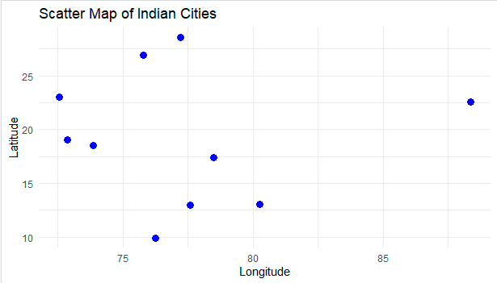

Q2. Plot a bubble map where bubble size represents population.
ggplot(cities, aes(x = Longitude, y = Latitude, size = Population)) +
geom_point(alpha = 0.7) +
labs(title = "Bubble Map of Indian Cities",
x = "Longitude",
y = "Latitude",
size = "Population (Millions)") +
theme_minimal()
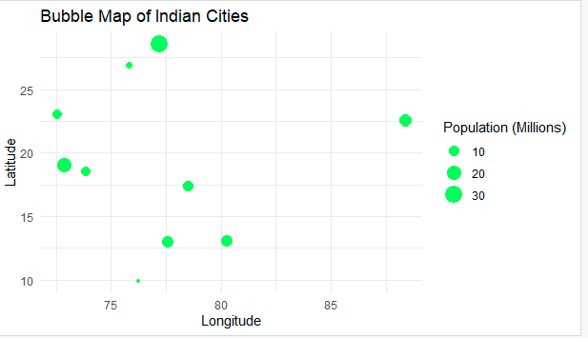

Q3. Label each city on the plot using geom_text().
ggplot(cities,
aes(x = Longitude,
y = Latitude,
size = Population)) +
geom_point(alpha = 0.7) +
geom_text(aes(label = City),
vjust = -1,
size = 3) +
labs(title = "Bubble Map with City Labels",
x = "Longitude",
y = "Latitude") +
theme_minimal()
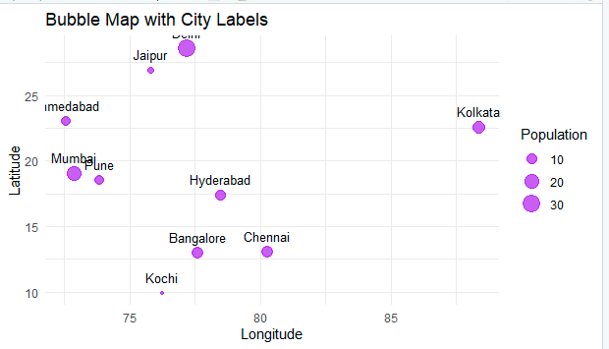

Q4. Use different colors based on population size.
ggplot(cities,
aes(x = Longitude,
y = Latitude,
size = Population,
color = Population)) +
geom_point(alpha = 0.8) +
geom_text(aes(label = City),
vjust = -1,
size = 3) +
scale_color_gradient(low = "blue", high = "red") +
labs(title = "Geospatial Bubble Map of Indian Cities",
x = "Longitude",
y = "Latitude",
color = "Population (Millions)",
size = "Population (Millions)") +
theme_minimal()
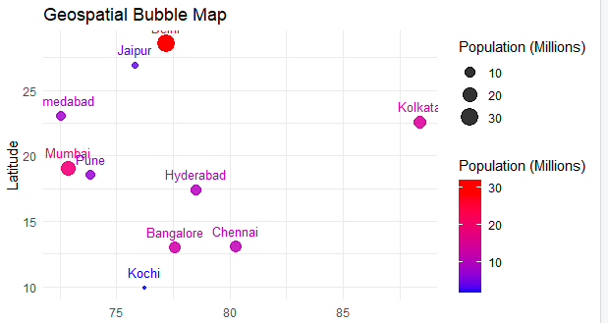

Q5. Identify the city with the highest population from the visualization.
Answer: Delhi has the highest population with 32 million people. It appears as the largest bubble and the darkest/red-colored point in the visualization.
2. Network Visualization
Dataset
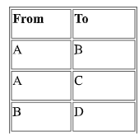
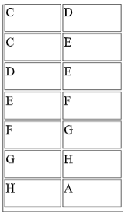
Questions
Q1. Create a network graph using the igraph package.
Q2. Display node labels and customize node colors.
Q3. Calculate the degree of each node.
Q4. Identify the node with the highest number of connections.
Q5. Plot the network using a circular layout.

Q1. Create a network graph using the igraph package.
# Install package (Run only once)
# install.packages("igraph")

library(igraph)

# Create Dataset
network <- data.frame(
From = c("A","A","B","C","C","D","E","F","G","H"),
To = c("B","C","D","D","E","E","F","G","H","A")
)

# Create Graph
g <- graph_from_data_frame(network, directed = FALSE)

# Plot Network Graph
plot(g,
main = "Network Graph",
vertex.size = 30,
vertex.color = "skyblue",
edge.color = "gray")
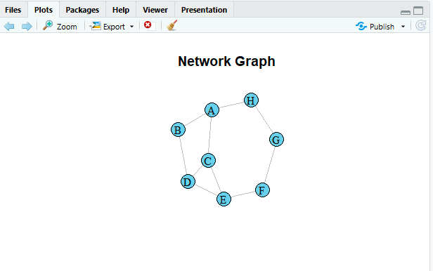

Q2. Display node labels and customize node colors.
library(igraph)
network <- data.frame(
From = c("A","A","B","C","C","D","E","F","G","H"),
To = c("B","C","D","D","E","E","F","G","H","A")
)
g <- graph_from_data_frame(network, directed = FALSE)

plot(g,
main = "Network Graph with Labels",
vertex.size = 30,
vertex.color = "orange",
vertex.label = V(g)$name,
vertex.label.color = "blue",
edge.color = "darkgreen")
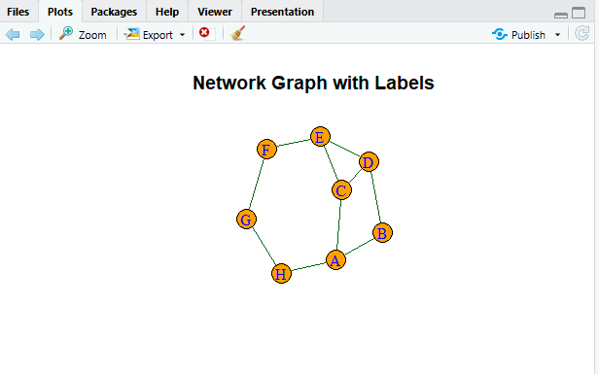

Q3. Calculate the degree of each node.
library(igraph)
network <- data.frame(
From = c("A","A","B","C","C","D","E","F","G","H"),
To = c("B","C","D","D","E","E","F","G","H","A")
)
g <- graph_from_data_frame(network, directed = FALSE)
degree(g)
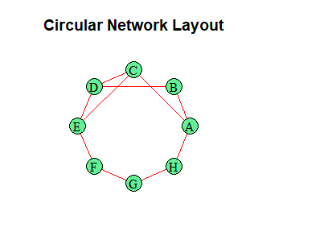

Q4. Identify the node with the highest number of connections.

library(igraph)

network <- data.frame(
From = c("A","A","B","C","C","D","E","F","G","H"),
To = c("B","C","D","D","E","E","F","G","H","A")
)

g <- graph_from_data_frame(network, directed = FALSE)

deg <- degree(g)

highest_node <- names(which.max(deg))

cat("Node with Highest Connections:", highest_node, "\n")
cat("Degree:", max(deg))
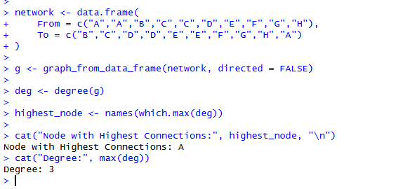

Q5. Plot the network using a circular layout
library(igraph)

network <- data.frame(
From = c("A","A","B","C","C","D","E","F","G","H"),
To = c("B","C","D","D","E","E","F","G","H","A")
)
g <- graph_from_data_frame(network, directed = FALSE)
plot(g,
layout = layout_in_circle(g),
main = "Circular Network Layout",
vertex.size = 30,
vertex.color = "lightgreen",
vertex.label.color = "black",
edge.color = "red")
3. Temporal Data Representation
Dataset
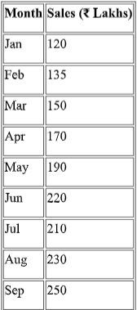
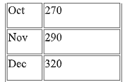
Questions:
Q1. Create a line chart showing monthly sales.
# Dataset
month <- c("Jan","Feb","Mar","Apr","May","Jun",
"Jul","Aug","Sep","Oct","Nov","Dec")

sales <- c(120,135,150,170,190,220,
210,230,250,270,290,320)
# Line Chart
plot(sales,
type = "l",
col = "blue",
lwd = 2,
xlab = "Month",
ylab = "Sales (₹ Lakhs)",
main = "Monthly Sales")
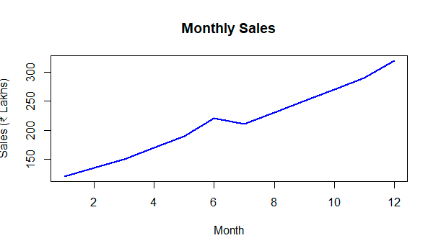

Q2. Add custom month names using the axis() function.
# Dataset
month <- c("Jan","Feb","Mar","Apr","May","Jun",
"Jul","Aug","Sep","Oct","Nov","Dec")

sales <- c(120,135,150,170,190,220,
210,230,250,270,290,320)
# Line Chart with Custom X-axis Labels
plot(sales,
type = "l",
xaxt = "n",
col = "blue",
lwd = 2,
xlab = "Month",
ylab = "Sales (₹ Lakhs)",
main = "Monthly Sales")
axis(1, at = 1:12, labels = month)
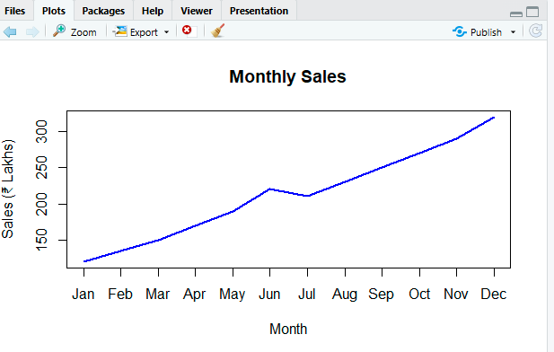
Q3. Highlight data points using pch=19.
# Dataset
month <- c("Jan","Feb","Mar","Apr","May","Jun",
"Jul","Aug","Sep","Oct","Nov","Dec")

sales <- c(120,135,150,170,190,220,
210,230,250,270,290,320)

plot(sales,
type = "o",
pch = 19,
col = "red",
lwd = 2,
xaxt = "n",
xlab = "Month",
ylab = "Sales (₹ Lakhs)",
main = "Monthly Sales with Data Points")
axis(1, at = 1:12, labels = month)
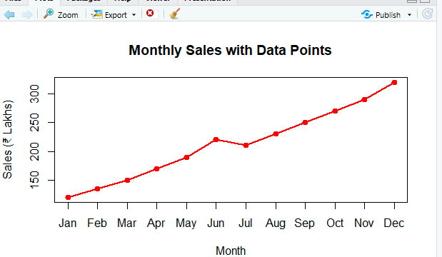
Q4. Display grid lines and proper axis labels.
# Dataset
month <- c("Jan","Feb","Mar","Apr","May","Jun",
"Jul","Aug","Sep","Oct","Nov","Dec")

sales <- c(120,135,150,170,190,220,
210,230,250,270,290,320)
plot(sales,
type = "o",
pch = 19,
col = "darkgreen",
lwd = 2,
xaxt = "n",
xlab = "Months",
ylab = "Sales (₹ Lakhs)",
main = "Monthly Sales")
axis(1, at = 1:12, labels = month)
grid()
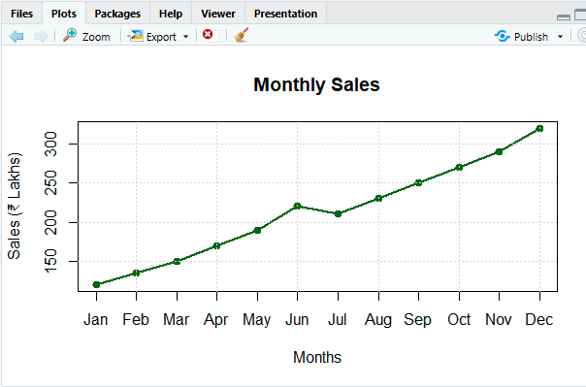
Q5. Identify the month with the maximum sales from the graph.
# Dataset
month <- c("Jan","Feb","Mar","Apr","May","Jun",
"Jul","Aug","Sep","Oct","Nov","Dec")

sales <- c(120,135,150,170,190,220,
210,230,250,270,290,320)

# Find Maximum Sales
max_month <- month[which.max(sales)]
max_sales <- max(sales)

cat("Month with Maximum Sales:", max_month, "\n")
cat("Maximum Sales:", max_sales, "Lakhs")
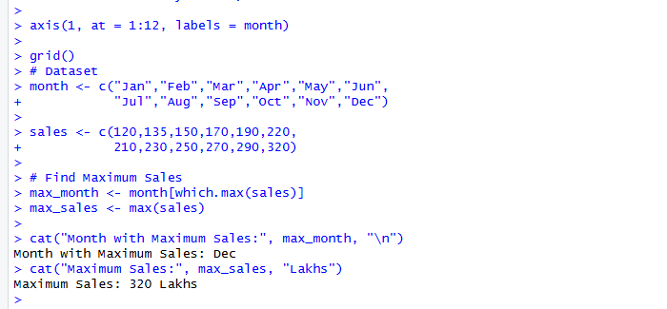
4. Multivariate Data Visualization
Dataset
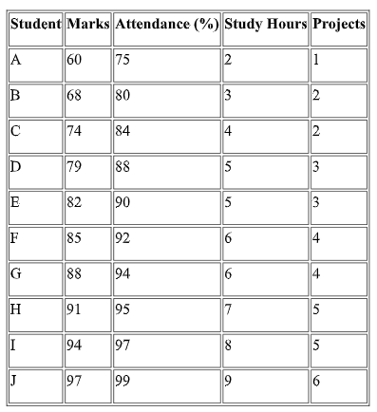
Questions:

Q1. Create a bubble plot
X-axis = Marks, Y-axis = Attendance, Bubble size = Study Hours
# Dataset
student <- data.frame(
Name = c("A","B","C","D","E","F","G","H","I","J"),
Marks = c(60,68,74,79,82,85,88,91,94,97),
Attendance = c(75,80,84,88,90,92,94,95,97,99),
StudyHours = c(2,3,4,5,5,6,6,7,8,9),
Projects = c(1,2,2,3,3,4,4,5,5,6)
)

plot(student$Marks,
student$Attendance,
cex = student$StudyHours,
pch = 19,
col = "blue",
xlab = "Marks",
ylab = "Attendance (%)",
main = "Bubble Plot")
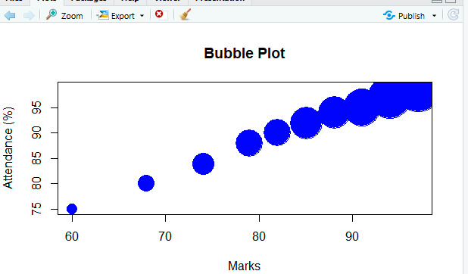

Q2. Produce a scatter plot matrix using the pairs() function.
# Dataset
student <- data.frame(
Marks = c(60,68,74,79,82,85,88,91,94,97),
Attendance = c(75,80,84,88,90,92,94,95,97,99),
StudyHours = c(2,3,4,5,5,6,6,7,8,9),
Projects = c(1,2,2,3,3,4,4,5,5,6)
)
pairs(student,
main = "Scatter Plot Matrix",
col = "red",
pch = 19)
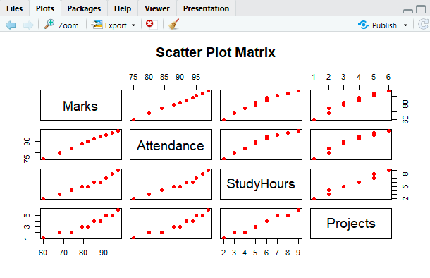

Q3. Find the correlation among Marks, Attendance, and Study Hours.
# Dataset
student <- data.frame(
Marks = c(60,68,74,79,82,85,88,91,94,97),
Attendance = c(75,80,84,88,90,92,94,95,97,99),
StudyHours = c(2,3,4,5,5,6,6,7,8,9)
)
cor(student)
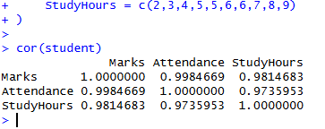

Q4. Identify the student with the highest marks and largest bubble.
# Dataset
student <- data.frame(
Name = c("A","B","C","D","E","F","G","H","I","J"),
Marks = c(60,68,74,79,82,85,88,91,94,97),
Attendance = c(75,80,84,88,90,92,94,95,97,99),
StudyHours = c(2,3,4,5,5,6,6,7,8,9)
)
highest <- student[which.max(student$Marks), ]
print(highest)
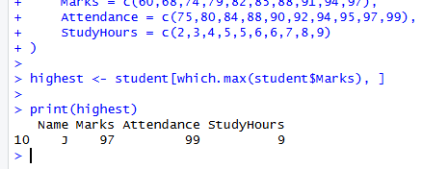

Q5. Create a heatmap showing the relationships among all numerical variables.
# Dataset
student <- data.frame(
Marks = c(60,68,74,79,82,85,88,91,94,97),
Attendance = c(75,80,84,88,90,92,94,95,97,99),
StudyHours = c(2,3,4,5,5,6,6,7,8,9),
Projects = c(1,2,2,3,3,4,4,5,5,6)
)
# Correlation Matrix
corr <- cor(student)
# Heatmap
heatmap(corr,
main = "Correlation Heatmap")
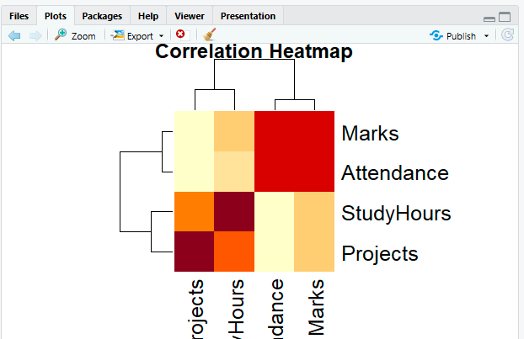

5. Integrated Data Visualization Exercise
Dataset
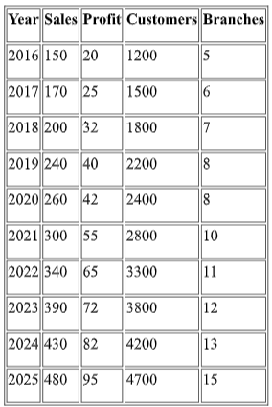

Q1. Create a temporal line chart showing yearly sales.
# Dataset
year <- c(2016,2017,2018,2019,2020,2021,2022,2023,2024,2025)
sales <- c(150,170,200,240,260,300,340,390,430,480)

# Line Chart
plot(year, sales,
type = "o",
pch = 19,
col = "blue",
lwd = 2,
xlab = "Year",
ylab = "Sales",
main = "Yearly Sales")
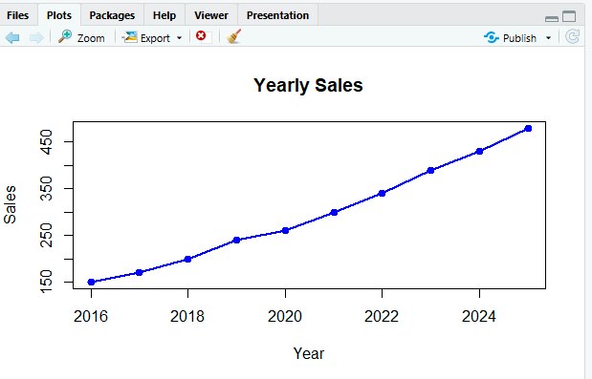

Q2. Generate a multivariate bubble plot
# Dataset
data <- data.frame(
Sales = c(150,170,200,240,260,300,340,390,430,480),
Profit = c(20,25,32,40,42,55,65,72,82,95),
Customers = c(1200,1500,1800,2200,2400,2800,3300,3800,4200,4700)
)

plot(data$Sales,
data$Profit,
cex = data$Customers/1000,
pch = 19,
col = "red",
xlab = "Sales",
ylab = "Profit",
main = "Bubble Plot")
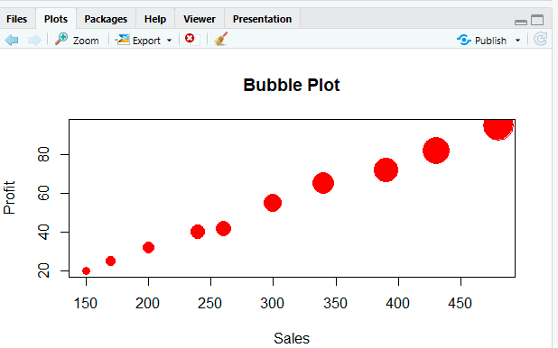

Q3. Compute the correlation matrix for Sales, Profit, Customers, and Branches.
# Dataset
data <- data.frame(
Sales = c(150,170,200,240,260,300,340,390,430,480),
Profit = c(20,25,32,40,42,55,65,72,82,95),
Customers = c(1200,1500,1800,2200,2400,2800,3300,3800,4200,4700),
Branches = c(5,6,7,8,8,10,11,12,13,15)
)

# Correlation Matrix
cor(data)
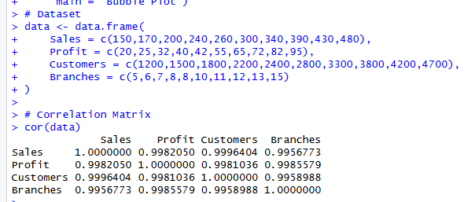

Q4. Create a scatter plot matrix using the pairs() function
# Dataset
data <- data.frame(
Sales = c(150,170,200,240,260,300,340,390,430,480),
Profit = c(20,25,32,40,42,55,65,72,82,95),
Customers = c(1200,1500,1800,2200,2400,2800,3300,3800,4200,4700),
Branches = c(5,6,7,8,8,10,11,12,13,15)
)

pairs(data,
main = "Scatter Plot Matrix",
col = "blue",
pch = 19)
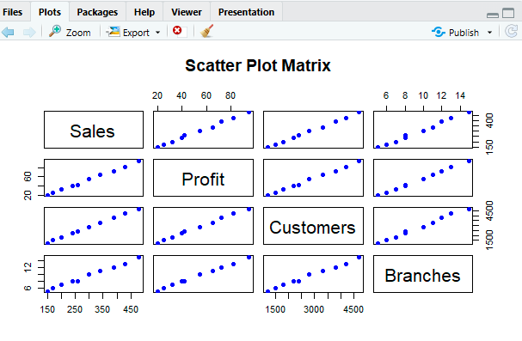

Q5. Interpret the visualizations to determine whether an increase in branches is associated with higher sales and profits.
# Dataset
data <- data.frame(
Sales = c(150,170,200,240,260,300,340,390,430,480),
Profit = c(20,25,32,40,42,55,65,72,82,95),
Customers = c(1200,1500,1800,2200,2400,2800,3300,3800,4200,4700),
Branches = c(5,6,7,8,8,10,11,12,13,15)
)

# Correlation Matrix
print(cor(data))

cat("\nInterpretation:\n")
cat("The visualizations show a strong positive relationship.\n")
cat("As the number of branches increases, both sales and profit also increase.\n")
cat("Therefore, an increase in branches is associated with higher sales and profits.\n")
